**COMPOUND**

**K T A C**

**_____ _____ _____ _____**

**25 25 25 25**

**_____ _____ _____ _____**

**25 25 25 25**

NAME: _________________

CLASS: ______

**TIME SIGNATURES**

**KNOWLEDGE**

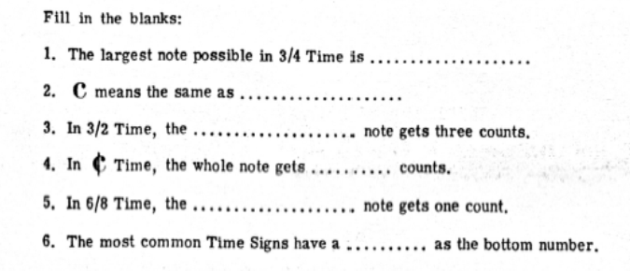

___

25

___

**THINKING**

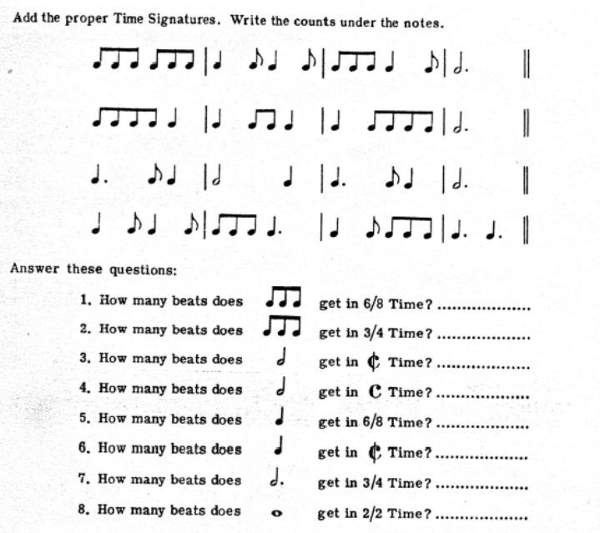

___

8

___

___

17

___

**APPLICATION**

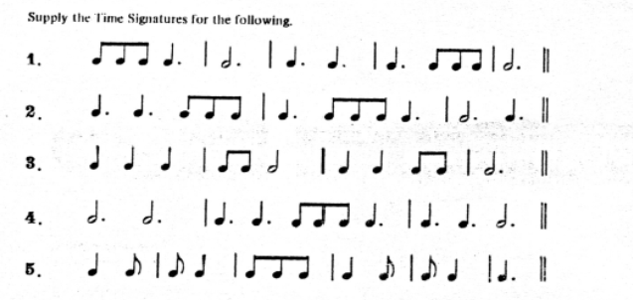

**Write the counts under the notes.**

___

___

25

___

**COMMUNICATION**

___

25

___



____________________________________________________________________________________

_________________________________________________________________________________________________________________________________________________________________________________________

_________________________________________________________________________________________________________________________________________________________________________________________

_________________________________________________________________________________________________________________________________________________________________________________________

_________________________________________________________________________________________________________________________________________________________________________________________